PIM L2 Syllabus Review Name:________________________

- What is the name of this course?
- What is the name of your teacher?
- List three of your five required daily materials:

- Identify and describe one of this course’s ethics:

- Who is your class partner?

PIM L2 Syllabus Review Name:________________________

- What is the name of this course?
- What is the name of your teacher?
- List three of your five required daily materials:

- Identify and describe one of this course’s ethics:

- Who is your class partner?
PIM L3 DO NOW! Name:________________________

MOTION

Know (write down everything you already know about the bold-faced topic):

Want to know (write down what you want to know the bold-faced topic):

Learned (after the unit is complete, write down what you learned about the bold-faced topic):

PIM L4 DO NOW (PIM TET)! Name:________________________

- Showing your work, solve for t.

t =

- Using the previous answer, set and rewrite it as a new equation.

t =

- Showing your work, solve for v.

v =

- Using the previous answer, set and rewrite it as a new equation.

v =

- Using the previous answer, set and graph the velocity equation as a function of time.
PIM L5 DO NOW! Name:________________________

- Determine the y-intercept, slope, & area “under the curve” (from 0 s to 3 s) for the following graphs:
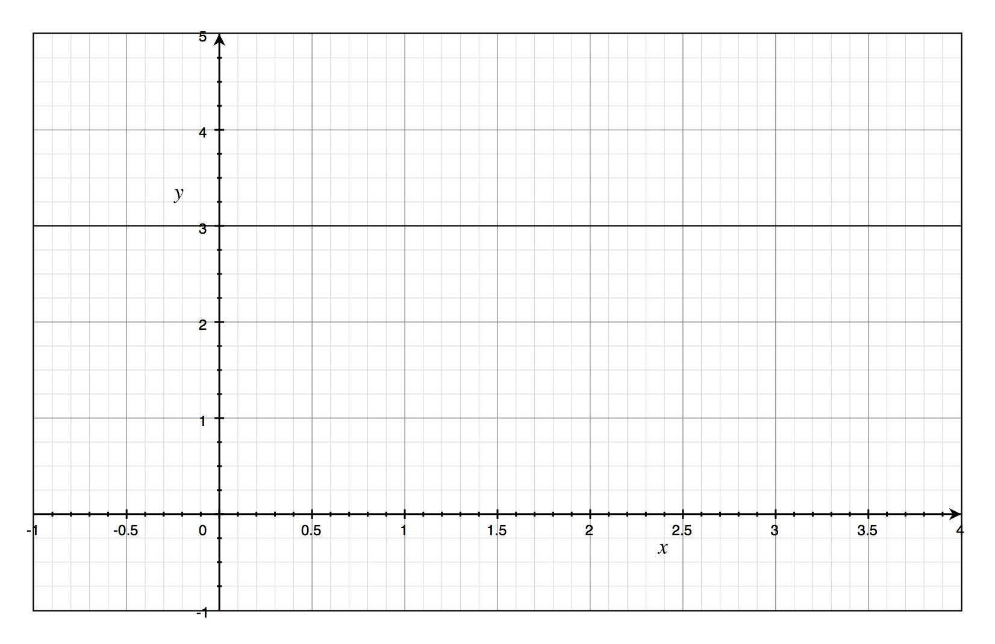
y-Intercept: Slope: Area (from 0→3):

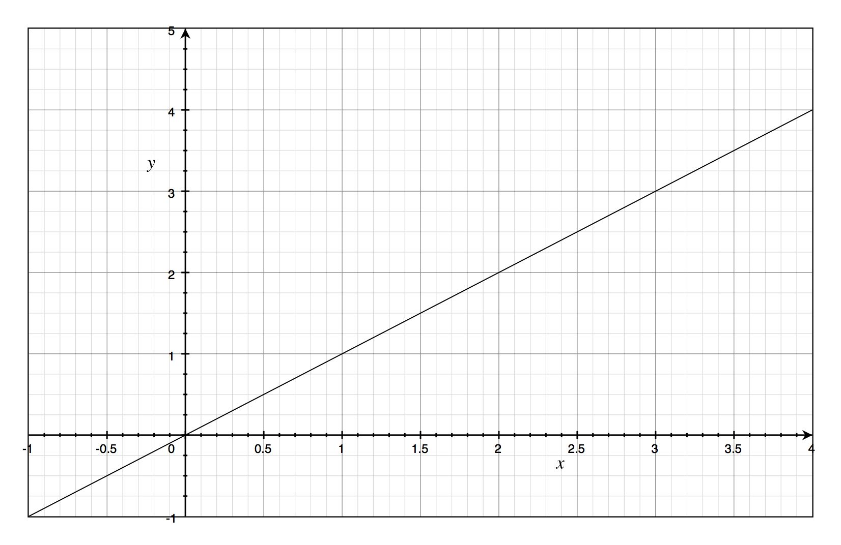
y-Intercept: Slope: Area (from 0→3):

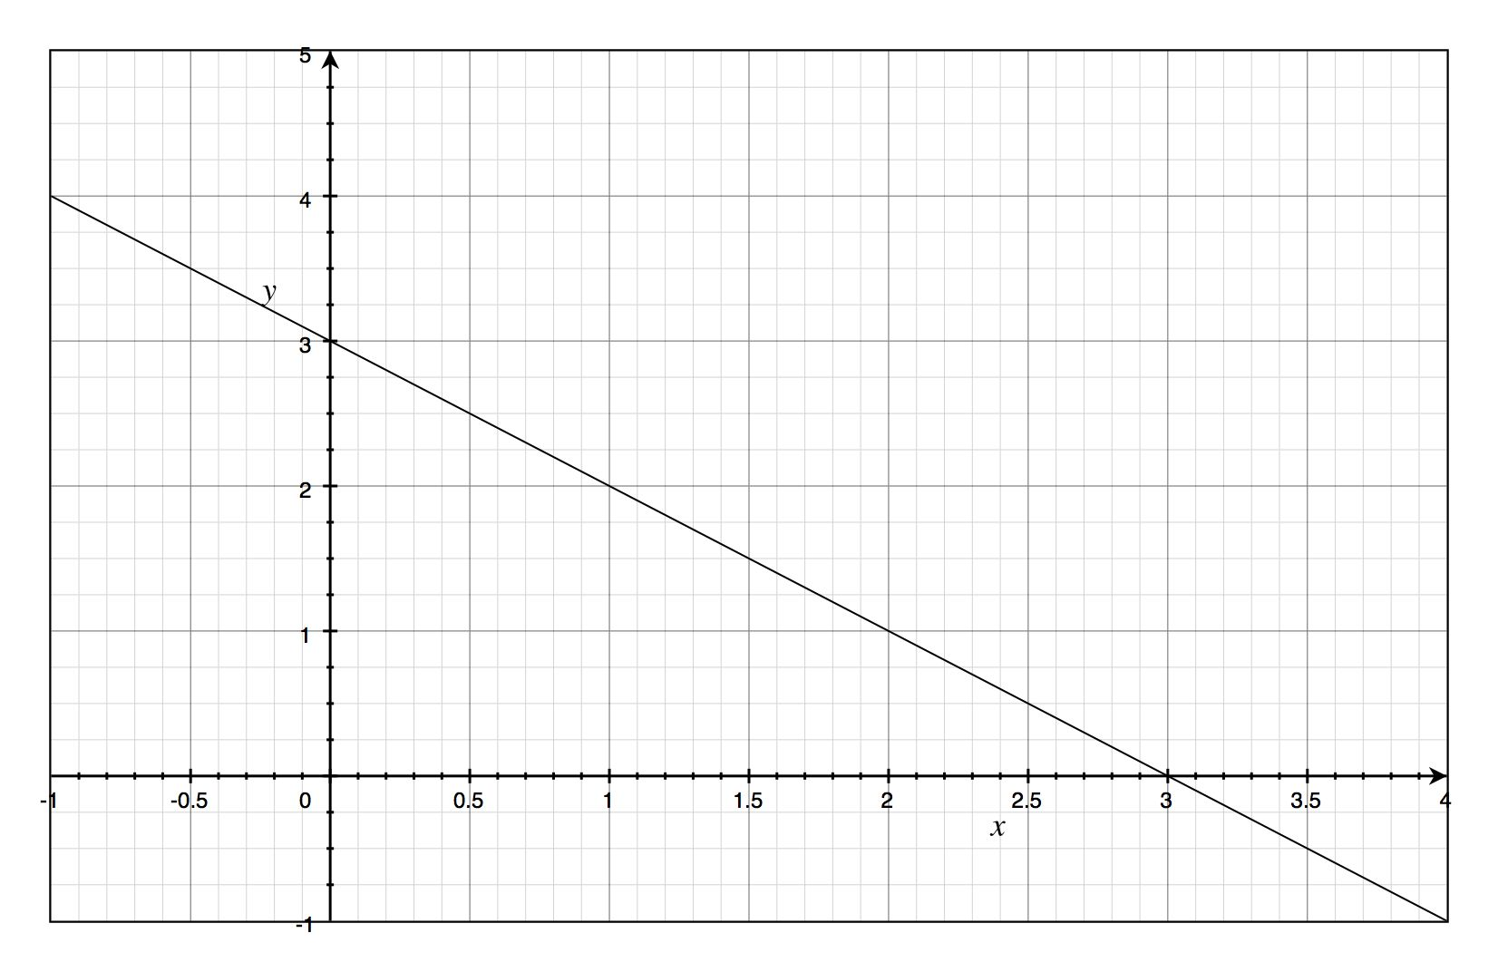
y-Intercept: Slope: Area (from 0→3):

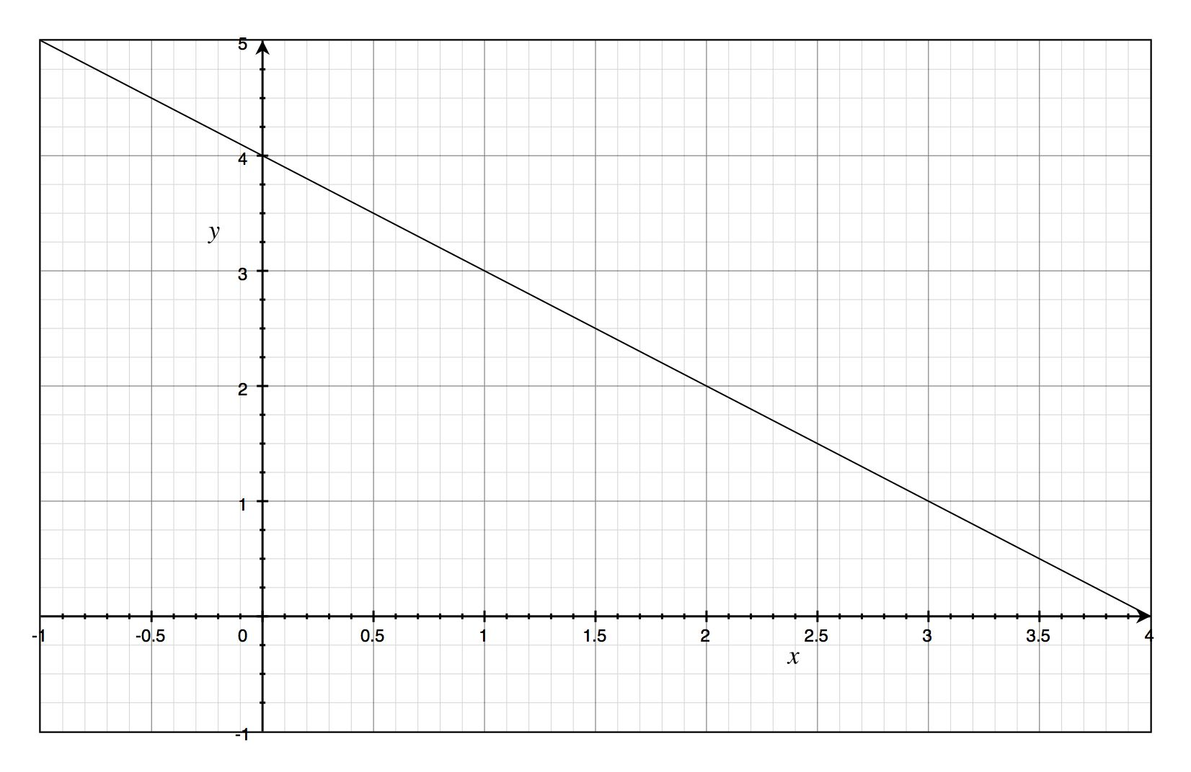
y-Intercept: Slope: Area (from 0→3):

PIM L6 DO NOW! Name:________________________

- Any measurement of position, distance, or speed must be made with respect to a ____________________.
- How far the object is from its starting point, regardless of how it got there is called ____________________.
- The measurement of the actual path traveled is called ____________________.
- The change in position is called ____________________.
- The formula for displacement is ____________________.
  - Δx = x₁ – x₂
  - Δx = x₂ – x₁
  - Δx = x₁ + x₂
  - Δx = x₁ – x₂ or Δx = x₂ – x₁
- If x₂ > x₁, then the displacement is ____________________.
- If x₂ < x₁, then the displacement is ____________________.
- If x₂ = x₁, then the displacement is ____________________.
- The unit for displacement is ____________________.
- What is Jerry-the-Race-Car-Driver’s TOTAL DISPLACEMENT if he drives 150 feet down the road before putting it into reverse to pickup his girlfriend that he left at a Richmond truck stop and has now walked 25 feet in the other direction before he arrives? (Note: Although it was not a positive move on his part to leave his girlfriend, let’s make his initial direction of motion “positive”)
- What is Jerry-the-Race-Car-Driver’s TOTAL DISTANCE TRAVELED if he drives 150 feet down the road before putting it into reverse to pickup his girlfriend that he left at a Richmond truck stop and has now walked 25 feet in the other direction before he arrives? (Note AGAIN: Although it was not a positive move on his part to leave his girlfriend, let’s make his initial direction of motion “positive”)

PIM L7 (Block Pt. 1) DO NOW! Name:________________________

- _______ Suppose that an object travels from one point in space to another. Make a comparison between the displacement and the distance traveled.
  - The displacement is either greater than or equal to the distance traveled.
  - The displacement is always equal to the distance traveled.
  - The displacement is either less than or equal to the distance traveled.
  - The displacement can be either greater than, smaller than, or equal to the distance traveled.

- _______ Suppose that an object travels from one point in space to another. When is the only time the displacement equals distance traveled.
  - When the displacement is in a straight line.
  - When the displacement is changes direction.
  - When the distance traveled is in a straight line.
  - When the traveled path changes direction.

- _______ An object moves 15.0 m north and then 9.0 m south. Find both the distance traveled and magnitude of the displacement vector. Let north be the positive direction.
  - 6.0 m, 24.0 m.
  - 24.0 m, 6.0 m.
  - 24.0 m, 24.0 m.
  - 6.0 m, 6.0 m.

- _______ An object moves 15.0 m north and then 9.0 m south. How would the directions of motion and the object’s final displacement be described as numbers. Let north be the positive direction.
  - 15.0 m, 9.0 m; 6.0 m.
  - 15.0 m, -9.0 m; -6.0 m.
  - 15.0 m, -9.0 m; 6.0 m.
  - -15.0 m, 9.0 m; -6.0 m.
  - Both c and d
  - All of the above
  - None of the above

- _______ An object moves 15.0 m north and then 9.0 m south. Graph the directions of motion (preferably in two different colors) and identify the object’s final displacement as an arrow. Let north be the positive x-direction.

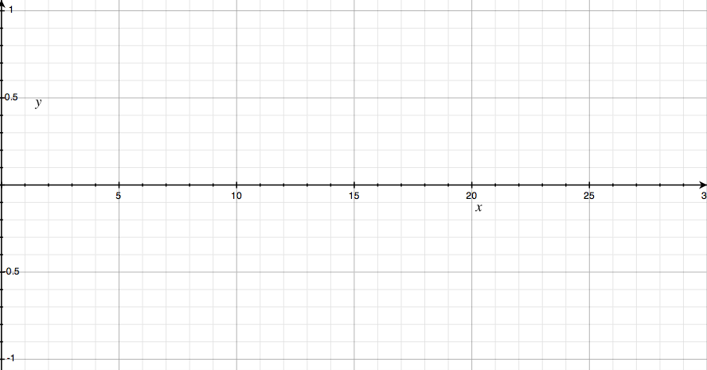

PIM L8 (Block Pt. 2) DO NOW! Name:________________________

Moon-walking Velocity Practice Problems
- What is the average velocity, v_{ave}, for a 1984 “moon-walking” pop-star moving across the stage from 10 m to 30 m in 20 s?
  - Identify what you are trying to find:
Find _____.
  - Identify the given information:
x₁ = _____
x₂ = _____
Δt = _____
  - Draw a picture.
  - Write down the formula that
contains v_{ave}, x₁, x₂, and Δt:
  - If necessary, algebraically solve
for the unknown.
  - Substitute the numbers and units
into the problem:
  - Write the answer with units:

- How much time does it take for a 1984 “moon-walking” pop-star traveling with a velocity of 5 m/s to travel across the stage from 10 m to 30 m?
  - Identify what you are trying to find:
Find _____.
  - Identify the given information:
x₁ = _____
x₂ = _____
v_{ave} = _____
  - Draw a picture.
  - Write down the formula that
contains v_{ave}, x₁, x₂, and Δt:
  - If necessary, algebraically solve
for the unknown.
  - Substitute the numbers and units
into the problem:
  - Write the answer with units:

PIM L9 DO NOW! Name:________________________

- If a car traveled for 30 minutes at 30 mph and then travels the next 30 minutes at 60 mph. . .

  - PREDICT: The car’s average speed is (less than, equal to, greater than) 45 mph.

  - How far did the car traveling during
the first 30 minutes?

  - How far did the car traveling during
the second 30 minutes?

  - How much time did the car travel?

  - What is the car’s average speed?

  - Extra Credit: Derive a general formula for the car’s average speed, v_{ave}, in this scenario in terms of t₁, s₁, t₂ , and s₂:

The following is homework tonight

- If a car traveled for 12 minutes at 30 mph and then travels the next 18 minutes at 60 mph. . .

  - PREDICT: The car’s average speed is (less than, equal to, greater than) 45 mph.

  - How far did the car traveling during
the first 12 minutes?

  - How far did the car traveling during
the second 18 minutes?

  - How much time did the car travel?

  - What is the car’s average speed?

  - Extra Credit: Calculate the car’s average speed using the general formula that you derived above:

- If a car traveled for 10 miles at 30 mph and then travels the next 10 miles at 60 mph. . .

  - PREDICT: The car’s average speed is (less than, equal to, greater than) 45 mph.

  - How long was the car traveling during
the first 10 miles?

  - How long was the car traveling during
the second 10 miles?

  - How far did the car travel?

  - What is the car’s average speed?

  - Extra Credit: Derive a general formula for the car’s average speed, v_{ave}, in this scenario in terms of d₁, s₁, d₂ , and s₂:

- If a car traveled for 5 miles at 30 mph and then travels the next 15 miles at 60 mph. . .

  - PREDICT: The car’s average speed is (less than, equal to, greater than) 45 mph.

  - How long was the car traveling during
the first 5 miles?

  - How long was the car traveling during
the second 15 miles?

  - How far did the car travel?

  - What is the car’s average speed?

  - Extra Credit: Calculate the car’s average speed using the general formula that you derived above:

PIM L10 DO NOW! Name:________________________

- _______ You and your dog go for a walk to the park. On the way, your dog takes many side trips to chase squirrels and examine fire hydrants. When you arrive at the park, do you and your dog both have the same displacement?
  - Yes
  - No
  - Only if you also chase squirrels and have an affinity for fire hydrants
- _______ Does a car speedometer measure speed, velocity, or both?
  - Speed
  - Velocity
  - Both Speed and Velocity
- When an object moves with constant velocity, does its average velocity during any time interval differ from its instantaneous velocity at any instant?
- Can an object have a varying speed if its velocity is constant? Explain.
- Can an object have a varying velocity if its speed is constant? Explain.
- During a 3.00 s time interval, Jerry-the-Race-Car-Driver's position changes from x₁=50.0 m to x₂=30.5 m. What was his average velocity? (Show your work)
- How far can Jerry-the-Race-Car-Driver travel in 2.5 h along a straight road if his average velocity is 18 km/h? (Show your work)

PIM L11 DO NOW! Name:________________________

How much time is needed for an admirer, running at 10 m/s, to catch up to the pop-star, traveling at 5 m/s, when they only 20 m apart? (SHOW ALL 7 STEPS)

PIM L11 DO NOW! Name:________________________

How much time is needed for an admirer, running at 10 m/s, to catch up to the pop-star, traveling at 5 m/s, when they only 20 m apart? (SHOW ALL 7 STEPS)
PIM L12 DO NOW! Name:________________________

- _______ When is the average velocity of an object equal to the instantaneous velocity?
  - Always.
  - Never.
  - Only when the velocity is constant.
  - Only when the velocity is increasing at a constant rate.

- _______ Suppose that a car travels from one point in space to another. When is the only time the average velocity equals speed at ALL times.
  - When the average velocity does not change direction.
  - When the average velocity changes direction.
  - When the car travels in a straight line at the same speed.
  - When the car travels in a straight line at different speeds.
  - When the car changes direction.
  - When the car changes its speed.

- _______ An object moves 15.0 m/s north for 1 min and then 9.0 m/s south for 1 min. How would the velocity and the object’s average velocity be described as numbers. Let north be the positive direction.
  - 15.0 m/s, 9.0 m/s; 6.0 m/s.
  - 15.0 m/s, -9.0 m/s; -6.0 m/s.
  - 15.0 m/s, -9.0 m/s; 6.0 m/s.
  - -15.0 m/s, 9.0 m/s; -6.0 m/s.

- _______ What must be your average speed in order to travel 350 km in 5.15 h?
  - 69.0 km/h.
  - 68.0 km/h.
  - 67.0 km/h.
  - 66.0 km/h.

PIM L13 DO NOW! Name:________________________

- _______ A car travels 90 km/h. How long does it take for it to travel 400 km?
  - 4.4 h.
  - 4.3 h.
  - 4.2 h.
  - 4.1 h.

- _______ If you run a complete loop around an outdoor track (400 m) in 100 s, your average velocity is __________.
  - 0.0 m/s.
  - 0.25 m/s.
  - 4.0 m/s.
  - 40 000 m/s.

- _______ A boat moving at 30 km/h is trying to catch a canoe
(12 km in front of it) that is moving at 6.0 km/h. How long will it take the boat to catch the canoe?
  - 20 min.
  - 24 min.
  - 30 min.
  - 36 min

PIM L14 DO NOW! Name:________________________

- Substitute directly into .

- For the previous general equation, set x₀ = 0, v = 0, and a = -10. Write the
new equation.

- Graph the displacement as a function of time [x(t)] for the special equation above.
50

40

30

20

10

- Using equation #3, determine the y-intercept and the slope of the line:

y – intercept: Slope:

- Using equation #3, determine the area “under the x(t) curve” from t = 0 to t = 2:

